**Next.js E-Commerce Web Application**

A full-stack e-commerce application developed using:

* **Frontend**: Next.js (React), Tailwind CSS
* **Backend**: Express.js
* **Database**: MongoDB (with Mongoose)
* **Authentication**: JSON Web Tokens (JWT)
* **Extras**:
  + **Maps**: @react-google-maps/api
  + **Charts**: recharts

**Table of Contents**

* [Features](https://github.com/Tusharberad/E-commerce-website-mern/blob/main/README.md#features)
* [Tech Stack](https://github.com/Tusharberad/E-commerce-website-mern/blob/main/README.md#tech-stack)
* [Project Structure](https://github.com/Tusharberad/E-commerce-website-mern/blob/main/README.md#project-structure)
* [Installation & Setup](https://github.com/Tusharberad/E-commerce-website-mern/blob/main/README.md#installation--setup)
* [Usage](https://github.com/Tusharberad/E-commerce-website-mern/blob/main/README.md#usage)
* [Screenshots](https://github.com/Tusharberad/E-commerce-website-mern/blob/main/README.md#screenshots)
* [Environment Variables](https://github.com/Tusharberad/E-commerce-website-mern/blob/main/README.md#environment-variables)
* [Future Enhancements](https://github.com/Tusharberad/E-commerce-website-mern/blob/main/README.md#future-enhancements)
* [Contributing](https://github.com/Tusharberad/E-commerce-website-mern/blob/main/README.md#contributing)
* [License](https://github.com/Tusharberad/E-commerce-website-mern/blob/main/README.md#license)

**Features**

* Browse and filter products
* Product detail pages with analytics charts
* Interactive maps for store locations or delivery areas
* Secure user authentication (login/signup with JWT)
* Shopping cart and checkout flow
* Admin panel for managing products and orders (if implemented)

**Tech Stack**

| **Layer** | **Technology** |
| --- | --- |
| Frontend | Next.js, React, Tailwind CSS |
| Backend | Express.js, Node.js |
| Database | MongoDB with Mongoose |
| Auth | JSON Web Tokens (JWT) |
| Extra | @react-google-maps/api, recharts |

**Project Structure**

├── app/ # Next.js application components  
├── components/ # Reusable UI elements  
├── pages/ # Route-based pages  
├── libs/ # Utility functions  
├── hooks/ # Custom React hooks  
├── public/ # Static assets (images, fonts, etc.)  
├── styles/ # Global and Tailwind styles  
├── next.config.ts # Next.js config  
├── tailwind.config.js # Tailwind CSS config  
└── ...other config files

**Installation & Setup**

1. Clone the repository:  
   git clone <https://github.com/Tusharberad/E-commerce-website-mern.git> cd E-commerce-website-mern

2.Install dependencies: {npm install}

3.Configure environment variables by creating a .env file: MONGO_URI=mongodb+srv://tinkuberad18:<db_password>@e-commerce441108.cc0cwfu.mongodb.net/

4.Run the development server: (npm run dev)

5.Visit the app at [http://localhost:3000](http://localhost:3000/)

**Future Enhancements:-**

User profile & wishlist

Complete checkout flow with payment gateway

Product reviews & ratings

Admin dashboard for content management

Product search, filters, and pagination

Localization and multi-currency support

**Contributing**

Contributions are welcome! Please follow:

1.Fork the repository

2.Create a feature branch:( https://github.com/Tusharberad/E-commerce-website-mern)

3.Make your changes and commit with a clear message

#Home page

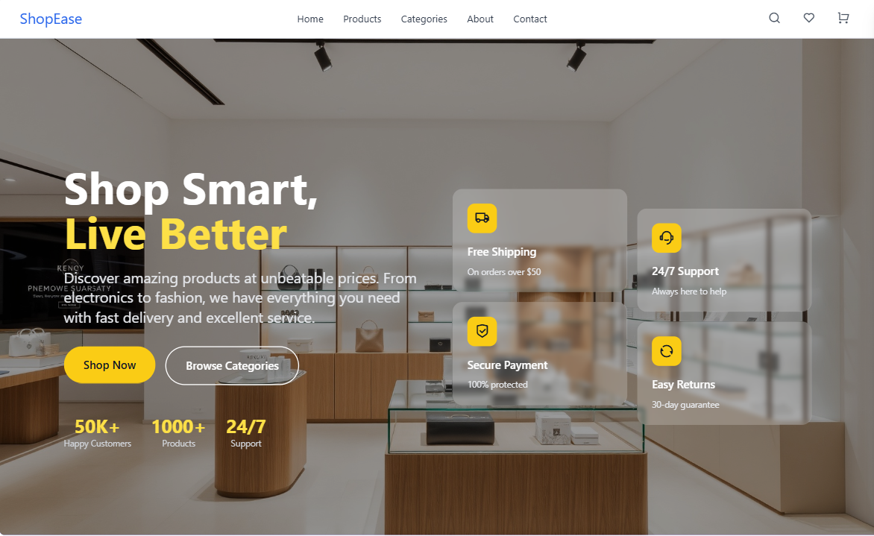

**#Current 50 product list**

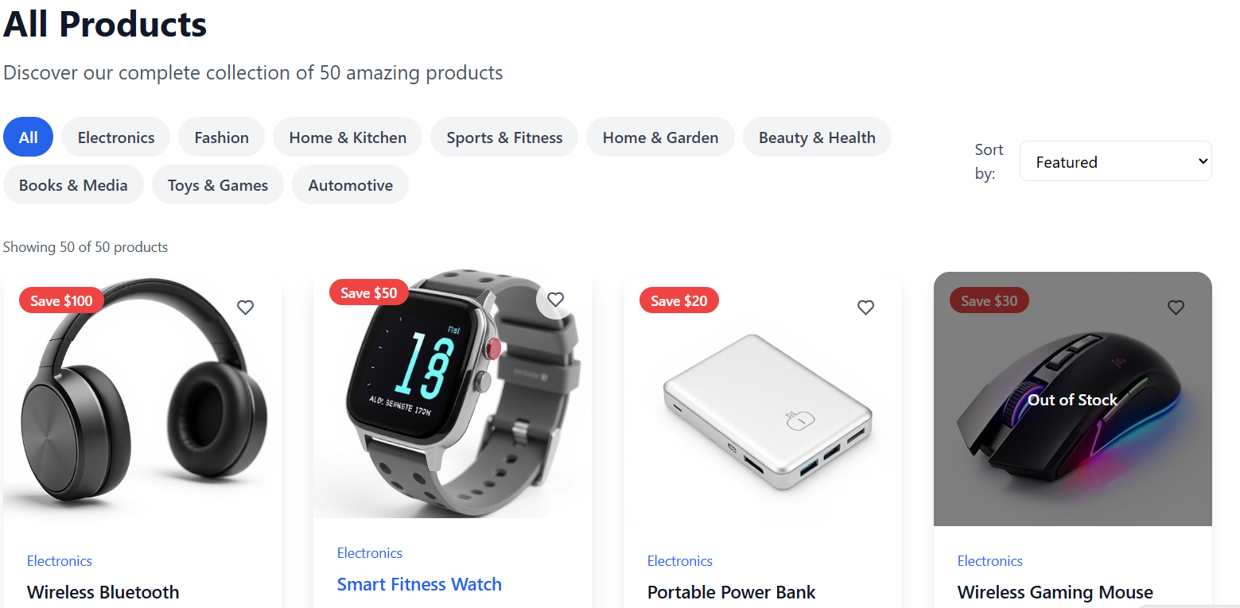

#Website analysis

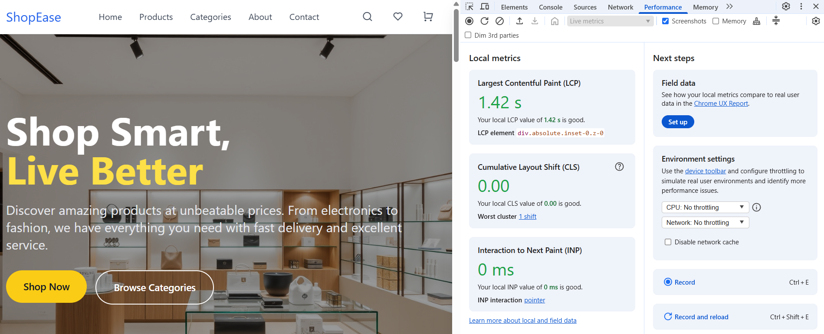

**#Product feature**

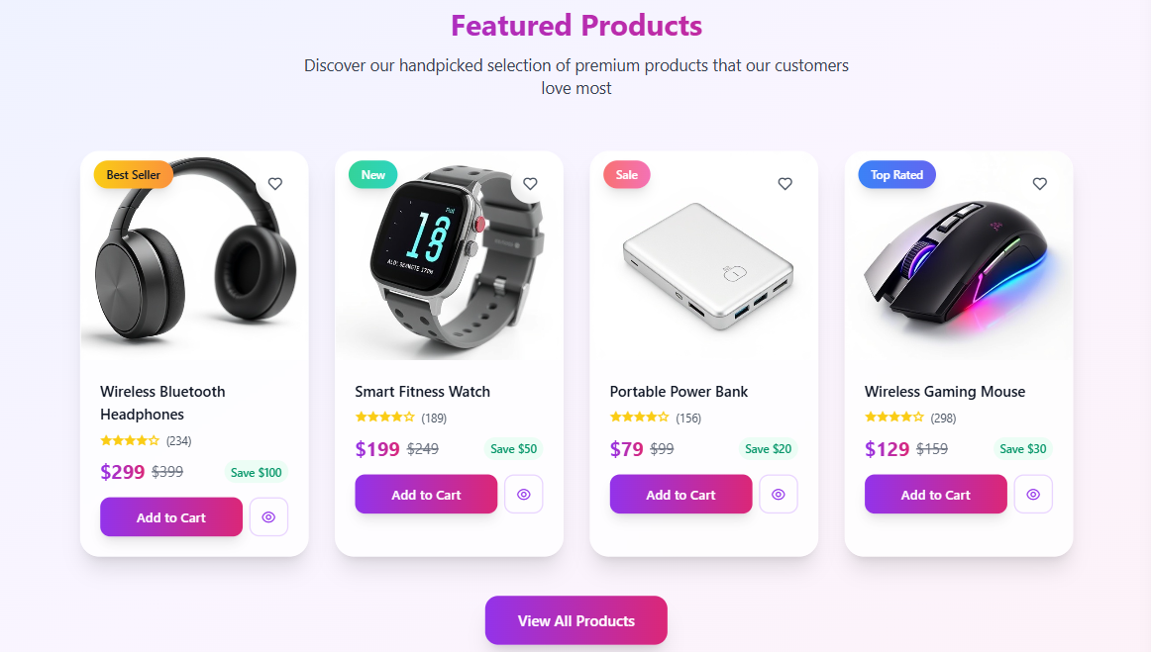

**#Categories**

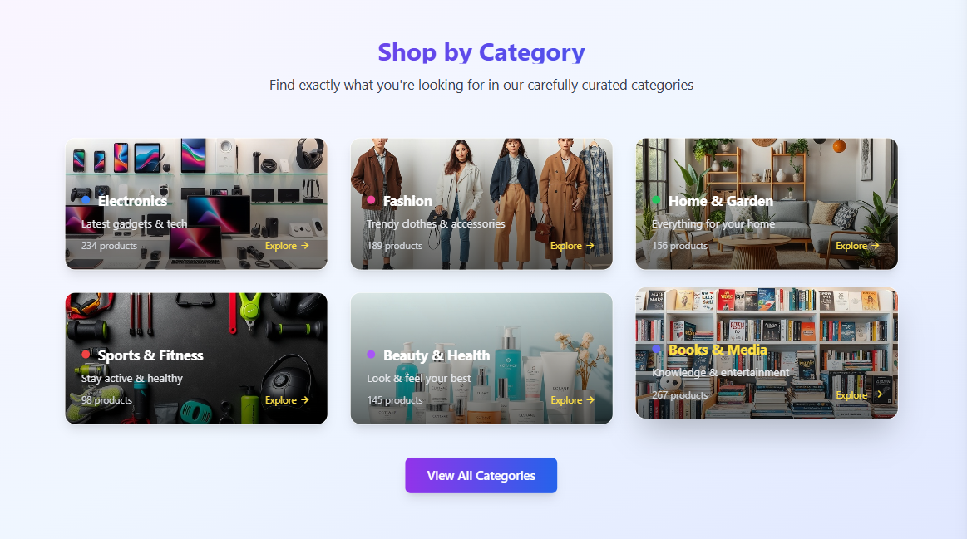

**#About**

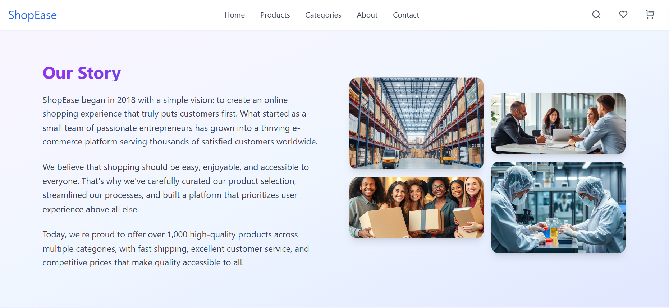

Thanks for watching